* Clamshell mode
  + Multiple-voices (default mode for passing SfB) -> mode 0x01
  + My-voice-only -> mode 0x03
  + Follow-my-voice -> 0x0B (reserved for future request from HP; not using currently)
* Table mode
  + Portrait 0 -> mode 0x07
  + Portrait 1 -> mode 0x08
  + Landscape 0 (= handheld mode, mics up) -> mode 0x04

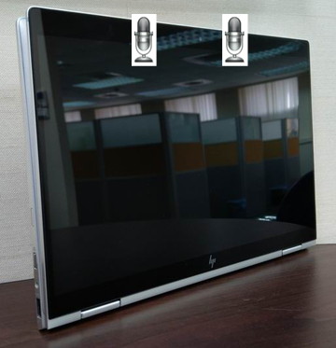

* + Landscape 1 (= tent mode, mics down) -> mode 0x05 (SfB secondary usage; to be tested @ PAL qualification as well with reduced test items)

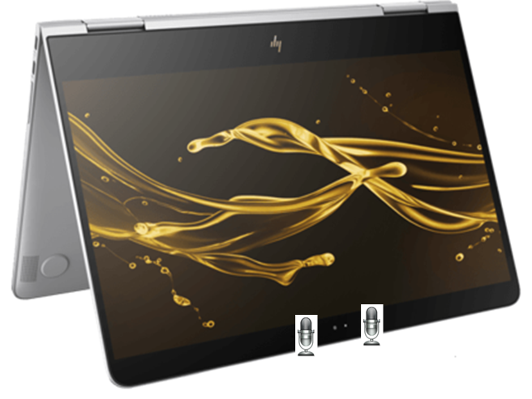

* Flat -> mode 0x06

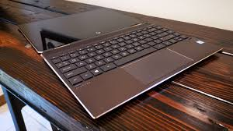

* Cortana (lid-open) -> mode 0x13
* Cortana (lid-close) -> mode 0x15
* HWKWS (Cortana supporting hardware keyword spotter) (lid-open) -> mode 0x1B
* HWKWS (Cortana supporting hardware keyword spotter) (lid-close) -> mode 0x1A
* VoIP (lid-close) -> mode 0x09
* Front-Left/Front-Right (FLFR) -> mode 0x11
  + Mic raw input test for factory production line
  + Back-Left/Back-Right mics must be set muted!
    - 0x2506 = 0x0000
    - 0x1FFD = 0x0000
    - 0x1FFF = 0x0400
    - Detail setting refer to <https://fortemediainc.sharepoint.com/:w:/s/PCNB/EZV17nOrkp9Itg9dUlXa2AYBmzMyY-wYHh9GCvD2Pmx0-g?e=0PrxPz>
* Back-Left/Back-Right (BLBR) -> mode 0x12
  + Mic raw input test for factory production line
  + Front-Left/Front-Right mics must be set muted!
    - 0x2506 = 0x0000
    - 0x1FFD = 0x0001
    - 0x1FFF = 0x0400
    - Detail setting refer to <https://fortemediainc.sharepoint.com/:w:/s/PCNB/EZV17nOrkp9Itg9dUlXa2AYBmzMyY-wYHh9GCvD2Pmx0-g?e=0PrxPz>

**** we can check parameter 0xF4 to see if the use case mode is matched

|  |  |  |
| --- | --- | --- |
| **** we can check parameter 0xF4 to see if the use case mode is matched. **Orientation / usage** | **Mode** | **Mic usage** |
| Clamshell / multiple-voices | 0x01 | 2-front(2019) or 2-front + 2-back (2020) |
| Clamshell / only-my-voice | 0x03 | 2-front + 1-back |
| Landscape0 / Handheld mode (mics up) | 0x04 | 2-front |
| Landscape1 / Tent mode (mics down) | 0x05 | 2-front |
| Portrait0 | 0x07 | 2-front |
| Portrait1 | 0x08 | 2-front |
| Flat | 0x06 | 2-front |
| Cortana (lid-open) | 0x13 | 2-front |
| Cortana (lid-close) | 0x15 | 2-back |
| HWKWS (lid-open) | 0x1B | 2-front |
| HWKWS (lid-close) | 0x1A | 2-back |
| VoIP (lid-close) | 0x09 | 2-back |
| FLFR | 0x11 | 2-front |
| BLBR | 0x12 | 2-back |